

LAB REPORT

**CSE2011 – DATA STRUCTURES AND ALGORITHMS LAB**

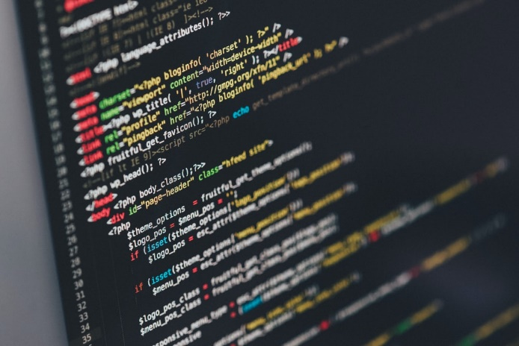

**(B.Tech. CSE Specialisation in Bioinformatics)**

**WINTER SEMESTER 2020-2021**

|  |  |
| --- | --- |
| **Name:** | ALOK MATHUR |
| **Reg. No:** | 20BCB0086 |
| **Slot:** | L51+L52 |
| **Faculty Name:** | SRIVANI A Ma’am |

**VIT – A Place to Learn; A Chance to Grow**